MESHTASTIC KIT OPTIONS

MTARA Demo Build: “The Picnic Hotspot” Node Short Name: PICN
Meshtastic Device:
https://store.rokland.com/products/rak-wireless-wisblock-meshtastic-starter-kit?_pos=2&_sid=ba962cde4&_ss=r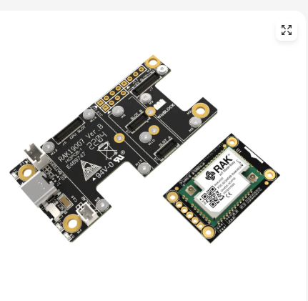
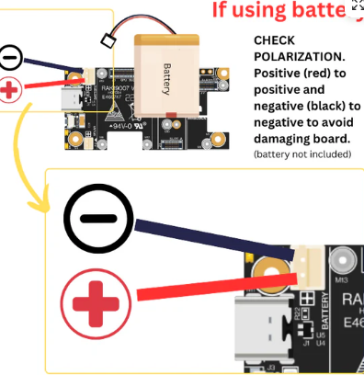

Short N Male Antenna:
https://store.rokland.com/products/alfa-aoa-915-2acm-2-dbi-omni-915mhz-802-11ah-mini-lora-antenna-meshtastic-n-male?_pos=7&_sid=17304e06c&_ss=r
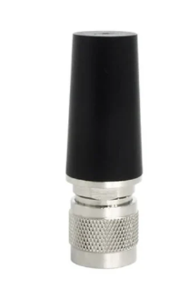

N Female Connector mounted to enclosure:
https://store.rokland.com/products/uflipex-ipx-mini-pci-to-n-female-bulkhead-pigtailble-extension-rg178

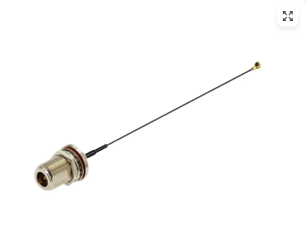

Flat Spring Contact 18650 Battery Holder: You need a FLAT TOP Battery (See Below)
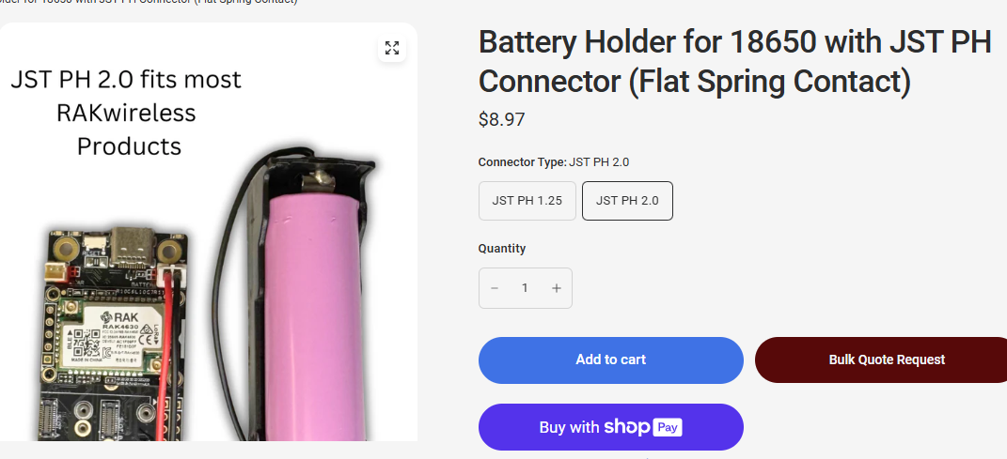
https://store.rokland.com/products/battery-holder-for-18650-with-jst-ph-connector?variant=42427390591059

Optional Longer Higher Gain N Male Antenna:
https://store.rokland.com/collections/802-11ah-wi-fi-halow/products/5-8-dbi-n-male-omni-outdoor-915-mhz-antenna-large-profile-32-height-for-helium-rak-miner-2-nebra-indoor-bobcat

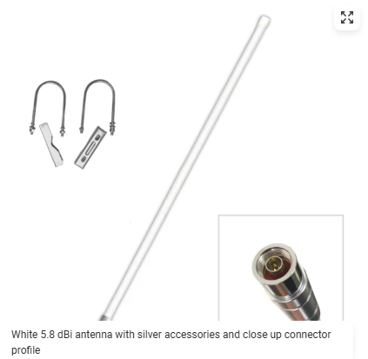

Solar Panel from RAK: (Note if you substitute your own, you’ll need to ensure it outputs no more than 5-6V DC and you will need to order RAK Cables: https://store.rokland.com/products/rak-wireless-solar-connector-cables-solar-wires-5pcs-pid-910116?_pos=1&_sid=c7ea62d28&_ss=r
The following solar panel works with the RAK Base Boards and comes complete with the proper polarization connector.
https://store.rokland.com/products/rakwireless-solar-panel-with-jst-1-5-connector-large-5-5-x-3-5-inch-sku-920433?_pos=1&_sid=81684d1fa&_ss=r

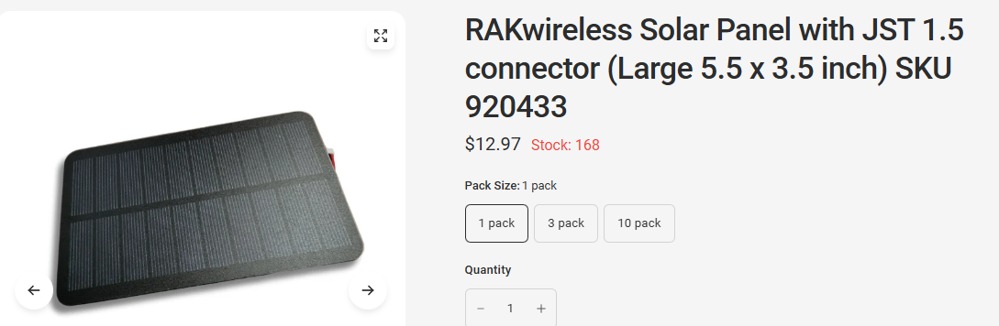

Parts From Amazon:
Enclosure:
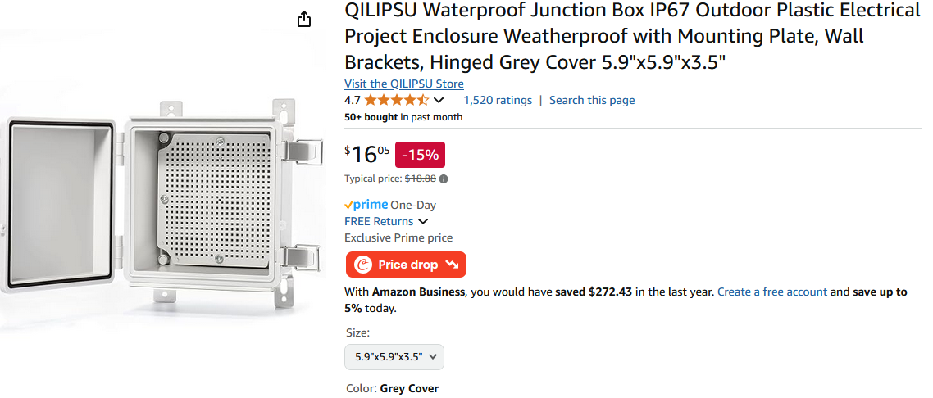
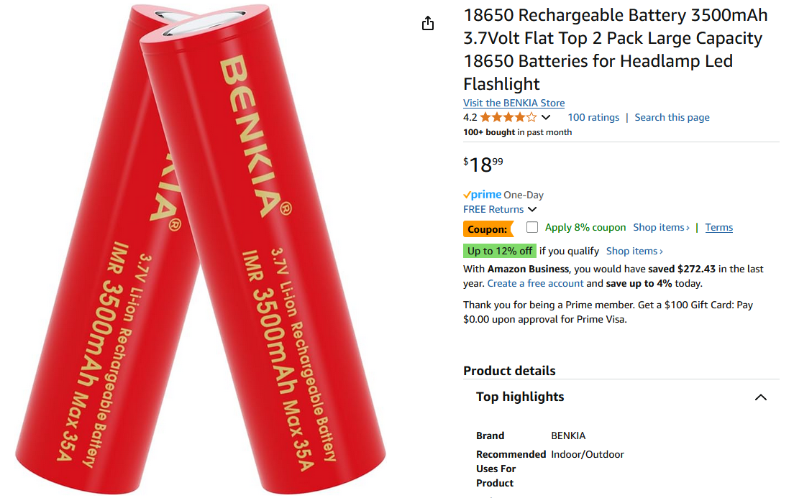

Wiring Options:
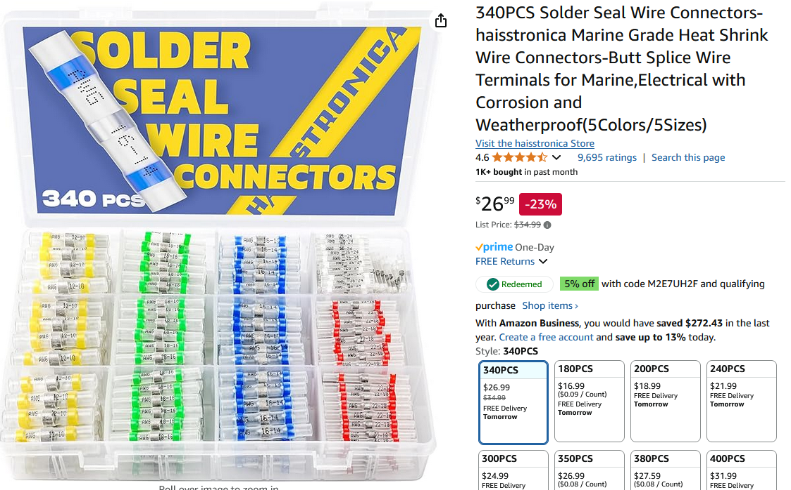
These were used to extend the silicone wire thru the enclosure and splice to the JST 1.5 Solar connector that plugs into the RAK Wireless board.
I unsoldered the wires from the solar panel and made a black/red braided pigtail from the solar panel & drilled thru the bottom of the enclosure’s lid, then spliced the desoldered Solar cable removed from the panel to this pigtail. This keeps the JST 1.5 connector intact and pluggable into the RAK Module.
The splices are inside the enclosure.

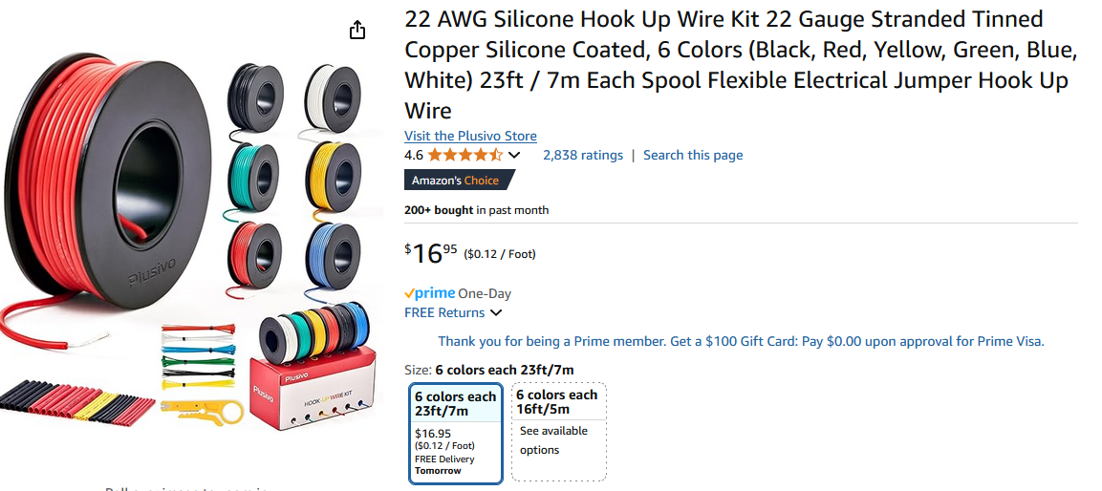

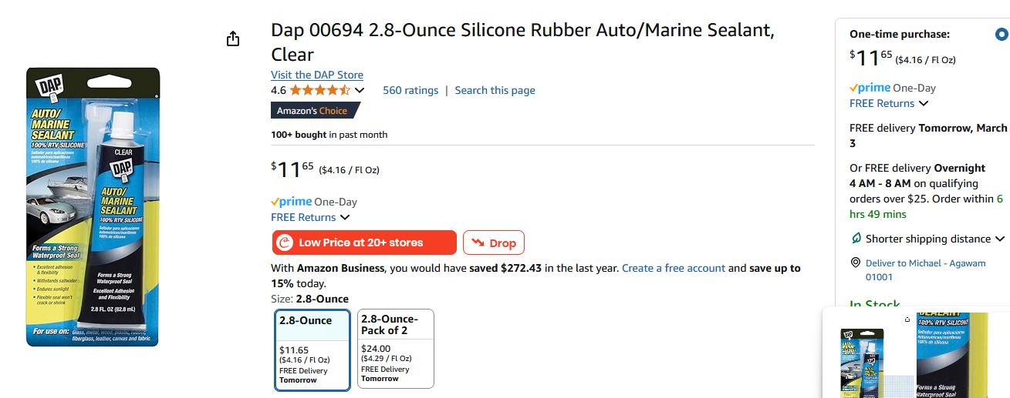
I used the above sealant to seal the entrance of the 1/8 inch hole drilled to pass the solar panel wires thru. I also 3D printed two 45 degree mounting blocks for the solar panel and used this RTV to mount the 3D printed blocks to the front of the enclosure.
I glued the solar panel to these mounting blocks with Loctite PLASTIC Cement I had on hand. This angles the solar panel 45 degrees from the front case face.

Software/Firmware:
This is to upgrade your device with the latest stable firmware using a USB C connection to your computer.
https://meshtastic.org/
https://flasher.meshtastic.org/ (You need CHROME or EDGE Browsers)
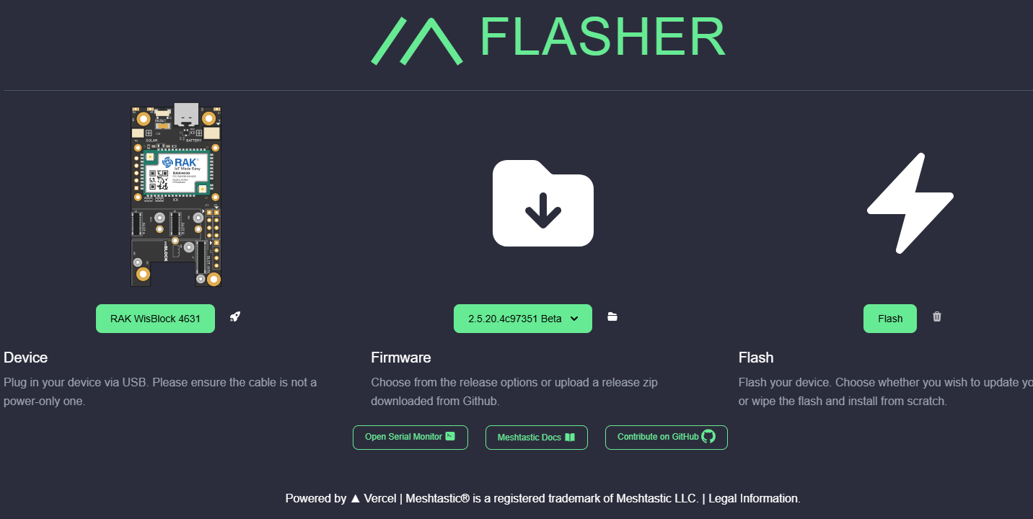
The RAK device will need to be placed in DFU mode. If the web flasher doesn’t do this, press the reset button on the RAK Module while you plug in the serial USB cable.

Download and install the iOS or Android Meshtastic app on your cell phone.
Once completed with the upgrade, you should be able to see the device from your iPhone or Android to pair with it. Then open up the Meshtastic APP and configure your device! The device will reboot automatically after each configuration step. iOS uses SAVE and Android uses SEND per below.
Set the Region to US (automatically reboots)
Under USER:
Type the Long Name, the Short Name fills in. Don’t set licensed ham.
You can pick a different 4 character or less short name. (SAVE or SEND and reboot)

Under BLUETOOTH:
Set the PIN to FIXED and type your desired PIN (SAVE or SEND, and reboot)
You can then unpair (forget) and repair your device to continue.
Under LORA:
Set the max hops to 5, the default is 3. (SAVE or SEND)
Verify the USE Preset is set to LongFast.
Under MQTT:
Set the slider to ignore MQTT: (SAVE or SEND, and reboot)

The device will have a single channel,
Android: Primary 0 LongFast
iOS: Blank Name (Default)

This is a common unencrypted channel using the key: AQ==

Refer to
PVMESH.ORG if you wish to participate in the Pioneer Valley Emergency Consortium for more configuration details. Read the discussion on Client or Client_Mute settings for your device.
Ham/ARES members and people just having fun are enjoying meshtastic in the Pioneer Valley!

-Michael Scantlen de KC1IZC

Some Build Photos:
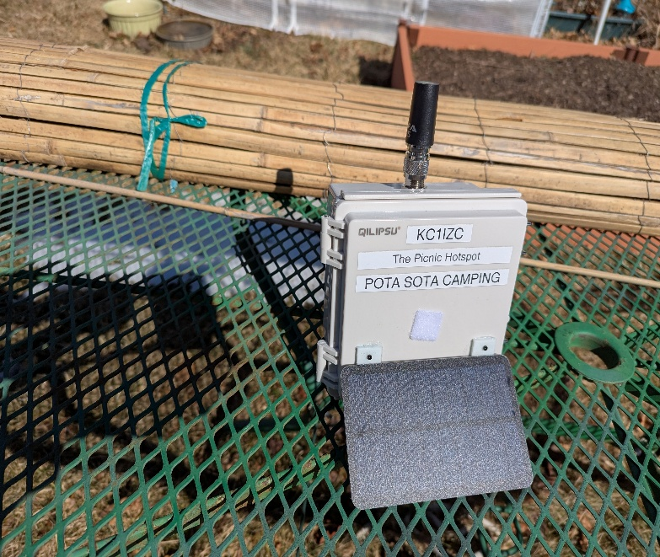
Figure 1: In its environment on a table outdoors!
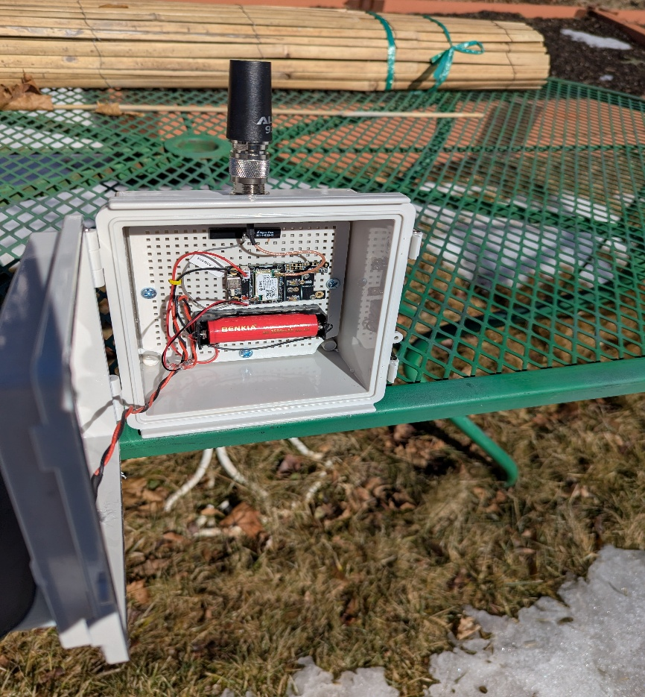
Figure 2: Powered up and running.
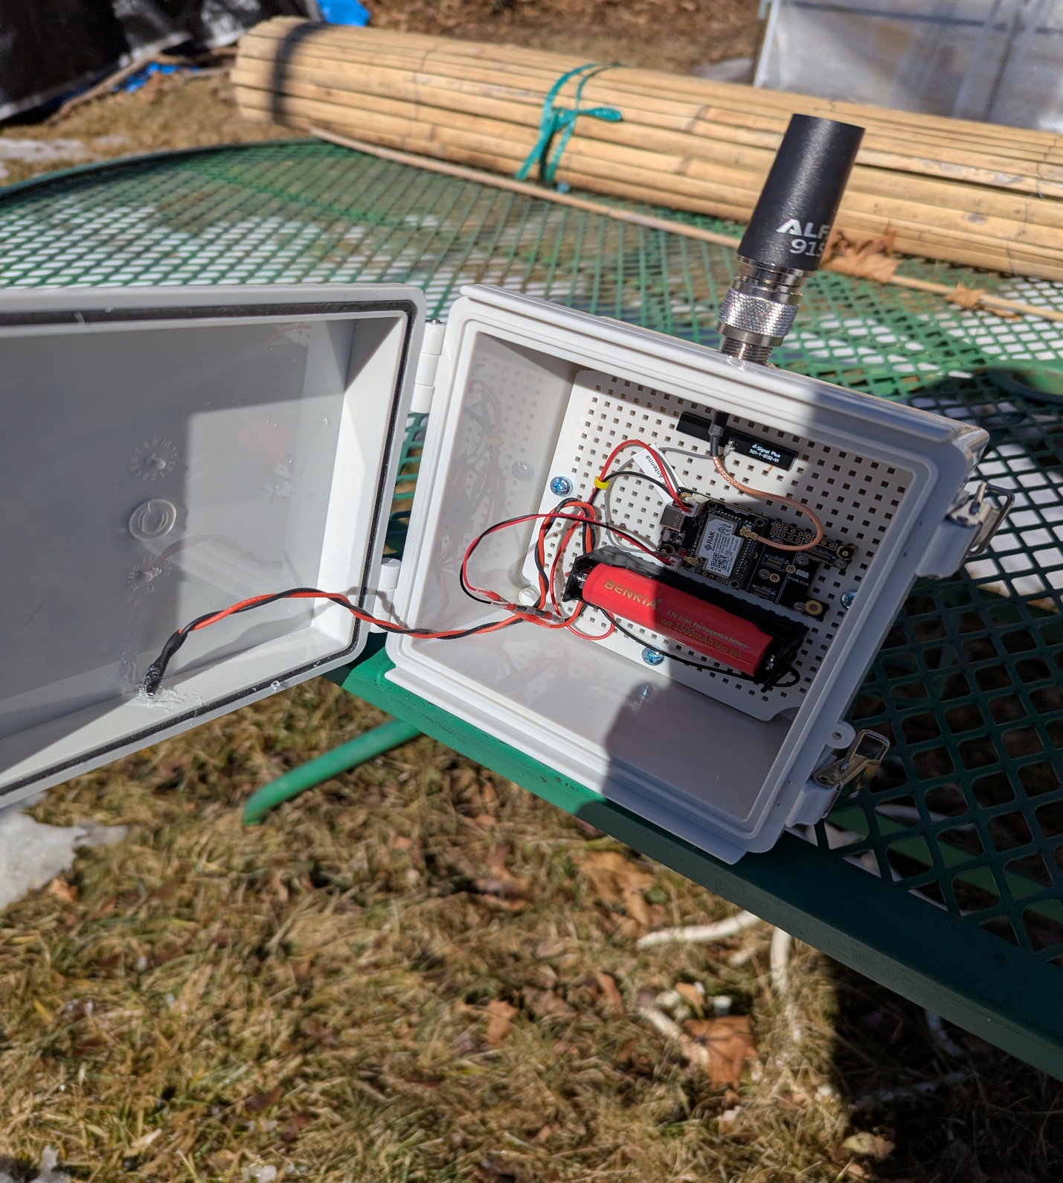
Figure 3: 1/8 Inch hole for custom braided silicone wire. Marine RTV applied.

Note: The solar panel is mounted on the hinged front case cover. This may be flat or angled with 3D printed 45 degree blocks.
- The RAK supplied Bluetooth antenna adhesive holds the antenna in place at the top of the perf board.
- Hardware of your choice mounts the battery holder, and the RAK Meshtastic starter kit module to the perf board.
- The N type bulkhead assembly is supplied with a sealing o-ring. You may apply silicone grease to this before assembly to improve water resistance.
The objective of this device is to offer a convenient central point where you and other members of your friends and family have a fixed point of broadcast for Meshtastic communication when outdoors. As suggested, this can be an RV, Picnic, POTA, SOTA or other outdoor gathering.
A rear mounted hose clamp facilitates non invasive mounting to a small diameter tree or flag pole at your RV site.

